Paul M. Summitt
312 Proctor Drive
Columbia, MO 65202
573-268-7209
Forgotten Missouri Pioneer Women
Three Kentucky Summit(t) Sisters and their daughters

George Summitt¹ was born somewhere around the year 1765² probably in Berkes County, Pennsylvania somewhere near Philadelphia³. His parents were Christian Summitt and Maria Stahlern⁴.

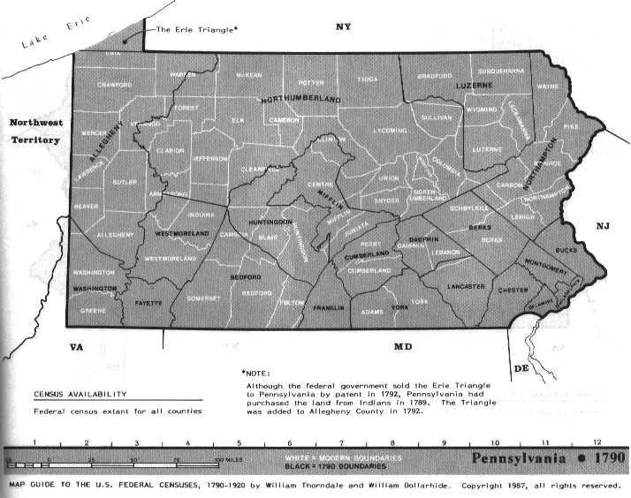
Christian more than likely arrived in Philadelphia from Germany on September 10, 1753, with his father, Jacob Summitt (Sammit)⁴. Only heads of households were listed by Captain Richey of the Ship Beulah so neither Jacob's wife nor his unmarried children would have been listed on the ship's entry documents. The list of these heads included eight Catholics and the rest, including Jacob, Lutherans. As Christian was born about 1735, he would have been around 17 or 18 in 1753 at the time of the family's arrival from Germany.
Christian married Maria Stahlern in Philadelphia on April 27, 1755⁵. He would have been about twenty at that time. Christian's first daughter that we are aware of, Maria Gertrand Summitt (Summit), was born five years later on March 13, 1760, and baptized at Trinity Lutheran Church in Reading in Berkes County⁶. Christian's first son that we are aware of, John, was born in Berkes County in 1761⁷. Another daughter, Susanna, is listed in the Trinity records as being born March 30, 1765, and baptized April 17, 1765⁸. As stated previously, Christian's son George is also estimated to have been born somewhere around the year 1765⁹. According to Virginia court records, Christian Sammet was involved during this time period in an assault and battery lawsuit with a Philip Emmert¹⁰ in Berkes County, Pennsylvania.
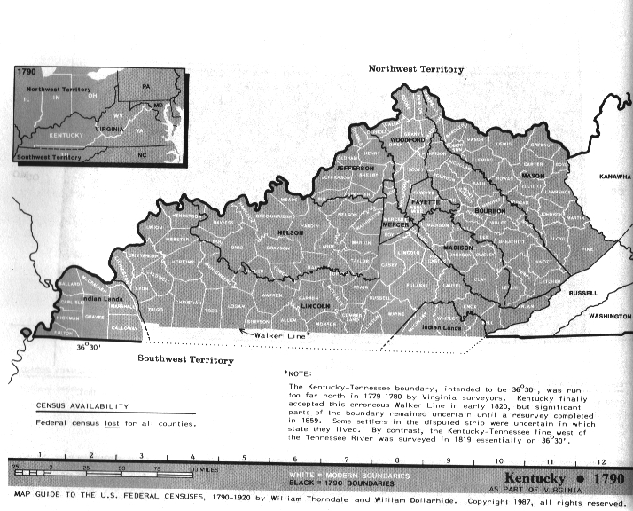
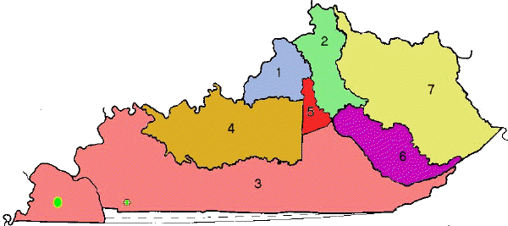
While it may appear confusing to the reader, this area of the country, that would later become parts of Pennsylvania, Kentucky, Virginia, and even later West Virginia, was in dispute between the colonies of Pennsylvania and Virginia during this time. On April 7, 1769, Jacob Sinnett received a land warrant from Pennsylvania for 300 acres¹¹. In August of 1778, Jacob Summit would be given a land grant by Lord Fairfax in the Northern Neck of Virginia in Hampshire County, an area that is now West Virginia¹². Christian Summitt (Summit) is found in Virginia court records for an area now covered by Washington County, Pennsylvania in a slander suit that ran from August 1777 through August of 1778¹³.
In 1780, fifteen-year-old George Summitt was living at Grant's Station in Kentucky. Located in Bourbon County, near the Fayette County line, the fort was built in 1779 only to be partially destroyed during an Indian attack in June of 1780. In a letter dated April 24, 1780, John Grant, founder of Grant's Station, wrote that George was living at Grant's Station in 1780, visited Sturgus Station on Bear Grass, also in 1780, and raised a crop of corn there. George was in the area of the Lower Blue Tick in 1782¹⁴. In 1783 Christian received a land grant of 325 acres from Virginia in Fayette County, Kentucky¹⁵. Both Christian and his son John are listed as witnesses on the Will of Paul Froman in Lincoln County, Kentucky dated April 28, 1783 and proved May 20, 1783. Christian was also one of the executors¹⁶.
George Summat married Rosanna Graham on October 2, 1789¹⁷. He was twenty-four and she was twenty-three¹⁸. Both George and Christian Summet appear in the 1790 Kentucky Census on tax lists¹⁹. Christian's name also appears on a petition to the Virginia Legislature requesting that mills be allowed to be constructed on the Licking River in Kentucky in 1790²⁰. George Summett appears in the roster as an Ensign in the Bourbon County 13th Regiment in 1792²¹. Christian Summet appears in the 1793 Bourbon County, Kentucky Personal Property Tas Records²². George Sumet then appears in Bourbon County, Kentucky Personal Property Tax Records for 1795, 1797, and 1799²³. Christian Sumet appears in Bourbon County Tax records for 1795, 1796, and 1797²⁴. Christian Summitt received two land grants in Bourbon County in 1798²⁵. Christian Sumet, again, is listed in Bourbon County, Kentucky Personal Property Tax Records for 1799²⁶.
Both Christian and George Sumet also appear in the 1800 Kentucky tax lists but this time in Nicholas County²⁷. Christian and George Summit appear in the Nicholas County, Kentucky Property Tax lists for 1801, 1802, 1803, and 1804²⁸. Christian Sumet and George Sumett appear in the Nicholas County 1805 tax lists²⁹. Christian and George Summit appear in the Nicholas County 1806, 1808, and 1809 tax lists³⁰. Both are also named as executors in the will of Thomas Foster dated 30 October 1808 in Nicholas County³¹.
Both Christian and George Summitt appear in Nicholas County during the 1810 Federal Census³². Christian Summitt is listed in the 1810 Nicholas County tax lists³³. The 1811 Tax lists for Nicholas County include Christ'n and George Sumit³⁴. The 1812 and 1813 Tax lists for Nicholas County include Christ'n and George Summitt³⁵. In 1814, Christian Summit sells 325 acres to George Summit and a Peter Snap, all of Nicholas county³⁶. Peter Snap is the brother of Margaret Snap, wife of John Summitt, Christian's oldest son. The 1814 Tax lists for Nicholas County list a Christian and George Summit while the 1815 Tax list for the same county lists a Christian and George Summet³⁷.
Christian died sometime around 1815 but George continues to be listed with the last name Summet for the 1816, 1817, 1820, and 1821 tax years; with the last name Summitt for the 1819, 1823, and 1825 tax years; and with the last name Summit for the 1822 and 1824 tax years all in Nicholas County³⁸. He's listed as George Summitt in the 1820 US Federal Census³⁹ and as Geo. Summet in the 1830 US Federal Census⁴⁰ there in Nicholas County. On his death 03 May 1838, George was buried in the Summitt-Snapp Cemetery near Walnut Grove in Nicholas County, Kentucky.
According to George Summitt's last will and testament⁴¹, George had four daughters⁴² and three sons. The daughters’ names were Malinda, Synthia (Cynthia), Charlotte, and Tina (Christina). The sons were Jacob, James, John, and Elijah. There were two other sons, however, Christopher and George W, who were not mentioned in the will as they had died in 1800 and 1816 respectively. There were also two daughters who apparently died in addition to Tina (Christina), who died seven years before her father, but she was mentioned in the will.
The twelve children were:
- Jacob Summitt, b. 23 Jan 1790, (Bourbon) Kentucky, d. 26 Sept 1871, (Nicholas) Kentucky, m. 24 Oct 1819 to Minerva Storey b. 28 Mar 1804 Delaware, d. 1 Jun 1833 (Nicholas) Kentucky.
- John Robert Summitt, Sr., b. 23 Dec 1790 (Bourbon) Kentucky, d. 6 Jul 1844 (Fleming) Kentucky, m. 16 Mar 1814 to Margaret Ricketts b. 20 Jun 1793 Pennsylvania, d. 7 Jun 1876 (Fleming) Kentucky.
- Possible Daughter b. About1790, d. Before 1820.
- Christopher Summitt, b. About 1790. d. Before 1800
- George W. Summitt, b. 10 Oct 1792 (Nicholas) Kentucky, d. Jan 1816 (Hardin) Kentucky.
- James H. Summitt, b. 10 Oct 1792 (Nicholas) Kentucky, d. Oct 1879 (Mercer) Missouri, m. 18 Oct 1818 to Mariah Barnett b. 30 Sept 1794 (Nicholas) Kentucky, d. 2 Jan 1878 (Nicholas) Kentucky.
- Elijah Summitt, b. 6 Nov 1795 (Bourbon) Kentucky, d. 27 Jan 1864 Millersburg (Bourbon) Kentucky, m. 21 Sept 1825 to Nancy P. Johnson b. 1806 d. 8 Dec 1872 (Nicholas) Kentucky.
- Possible Daughter b. About 1795 d. Before 1820.
- Malinda Summitt b. About 1796 (Bourbon) Kentucky, d. Before 1896. m. 5 Mar 1820 (Nicholas) Kentucky to Andrew A. Ashbrook Sr. b. About 1805 (Bourbon) Kentucky, d. 27 Aug 1853 (Harrison) Kentucky.
- Cynthia Ann Summitt b. About 1797 Kentucky, d. 3 Aug 1880 Fulton (Callaway) Missouri, m. 25 Oct 1821 (Nicholas) Kentucky to James Hook b. 10 Jun 1793 Kentucky, d. 15 Mar 1850 (Benton) Missouri.
- Christina Summitt b. About 1801 (Nicholas) Kentucky d. 16 Jan 1831 (Callaway) Missouri, m. 21 Oct 1819 (Nicholas) Kentucky to John Duval West b. 18 May 1796 Paris (Bourbon) Kentucky, d. 29 Jun 1881 (Callaway) Missouri.
- Charlotte Summitt b. About 1801 (Nicholas) Kentucky, d. Before 1901 (Nicholas) Kentucky. m. 31 Jan 1816 Carlisle (Nicholas) Kentucky to Michael West b. About 1801 (Nicholas) Kentucky d. Before 3 July 1824 (Nicholas) Kentucky. m. 3 July 1834 (Nicholas) Kentucky to John Smith Wyatt b. 20 Sept 1796 (Warren) Missouri, d. 11 Oct 1854 Missouri.
Notice that the three youngest daughters have connections to Missouri. It is the oldest of the three, however, Cynthia Ann, who is of primary interest in this article. But let's turn our attention first to Charlotte and her Missouri connection and then to Christina and her Missouri connection.

Charlotte Summitt

Christina Summitt

Cynthia Ann Summitt
Cynthia Ann Summitt Hook and her husband, James Hook got married in Nicholas County, Kentucky on 25 October 182143 and are in Columbia, Boone County, Missouri in 182644. This probably means that Cynthia Ann is one of the two 16 to 26 year old females in George's 1820 household. The 1830 Census45 has James and Cynthia Ann in Callaway County, Missouri and has the household consisting of one male 30 to 39, probably James, one female 30 to 39, probably Cynthia Ann, two females 5 to 9, probably C.K. and L.C., and two females under five, probably Mary Ann and Hester. The 1840 Census46 finds the family in Montgomery Township, Benton County, Missouri and consisting of one male 40 to 49, James, one female 40 to 49, Cynthia Ann, two females 10 to 14, probably C.K. and L.C., two females 5 to 9, probably Mary Ann and Hester, and two females under 5, probably Nancy Jane and Julia.
With James death in 1850, Cynthia is the 53-year-old head of household in the 1850 Census for Alexander Township, Benton County, Missouri47. Other members of the household included 27-year-old female C. K. Hook, 25-year-old female L. C. Hook, 22 year old female Mary A Hook, 21 year old female Hester Hook, 19 year old female Nancy Hook, and 16 year old female Julia Hook. Cynthia and her family are missing from the 1860 census but show up in Bourbon Township, Callaway County, Missouri in the 1870 Census48. The head of the household is 27-year-old James Ficklin who is married to 38-year-old Mary Ann Hook Ficklin. Also living in the home are Cynthia Ann Hook, age 70, and 31-year-old Nancy J. Hook. Cynthia last shows up in the Fulton, Callaway County, Missouri 1880 Census49 taken 7 June 1880 and Cynthia died 3 August 1880. She is listed as 83 years old. Also in the household are James W. Ficklin age 37 and Nancy J Hook age 47. Mary Ann Hook Ficklin died 30 August 187950. Using the age data for Cynthia in these census reports, the best estimate for her birth year would be about 1797 making Cynthia one of the 10- to 15-year-old females in George's household in 1810.

End Notes
- In various documents this last name is spelled in a variety of ways including Summitt, Summit, Sammet, Sammit, and Shumate just to name a few. For clarity in this document, the author has decided to spell it the same as his own but will notate the different spellings in the various documents.
- In a deposition George Summitt made and filed in November of 1805 in Franklin Co., Kentucky, he stated that he was forty years old and that he came to Kentucky in 1780. Source: Ardery, Kentucky Court and Other Records, Vol. 2, p. 141. [Franklin County was not formed until 1795] As the date of the deposition was November 11, 1805, this would suggest his date of birth fell some time between November 12, 1764, and November 10, 1765.
- While some records suggest George was born in Westmoreland County, Pennsylvania, according to "Trinity Lutheran, Reading, Pennsylvania An Alphabetized Compilation of Baptisms, Marriages, and Deaths from 1751-1904" Prepared by Jacqueline B Nein and Gail H Hesser; 1988, Christian and Maria were in Berkes County for the baptism of their daughter Suzanna as late as April 17, 1765 who had been born on March 30, 1765. This would suggest he was more than likely born in Berkes County.
- Jacob Sammet and his family arrived in Philadelphia, PA on September 10, 1753 via the SS Beulah from Rotterdam according to Strassburger, Ralph Beaver. Pennsylvania German Pioneers: A Publication of the Original Lists of Arrivals in the Port of Philadelphia from 1727 to 1808. Edited by William John Hinke. Norristown, PA: Pennsylvania German Society, 1934. 3 vols. Vol 1 and 3 reprinted by Genealogical Publishing Co., Baltimore, 1964. Repr. 1983. Vol 1. 1727-1775. 776pp.
- Wright, F. Edward. Early Records of the First Reformed Church of Philadelphia; Volume 1; 1748-1780. 2011, Colonial Roots, Lewes, Delaware. p. 126.
- Nein, Jacqueline B. And Hesser, Gail H. Trinity Lutheran, Reading, Pennsylvania: An Alphabetized Compilation of Baptisms, Marriages, and Deaths from 1751-1904. 1988.
- Ibid.
- Ibid.
- In a deposition taken before the Franklin County Circuit Court on November 11, 1805, George gives his age as 40 years old. Depositions Box 411, Kentucky Court Records, Franklin County Circuit Court, Frankfort, Kentucky.
- Civil Court Docket; Berkes County, August Term 1765; Parties and Proceedings. Philip Emmert vs. Christian Sammett Alias Copias Assault and Battery.
- Index of Early Pennsylvania Land Warrants, 1733-1987 from the Pennsylvania State Archives. Stevens, Pennsylvania: Ken McCrea, 2010.
- August 1778, Jacob Sammet given land grant by Lord Fairfax in Northern Neck of Virginia in Hampshire County, now West Virginia of 154 acres.
- Virginia Court Records located in Washington County, PA.
- http://www.gesswhoto.com/olden-daze/index31.html
- Book 8, p. 47. Surveyed 1-7-1783. Watercourse: Hinkston Fork. Jillson, Old Kentucky Entries and Deeds, p. 150.
- The Will of Paul Froman, April 28, 1783, Will Book A, p. 46, Lincoln county, Kentucky, recorded 20 May 1783.
- Dodd, Jordan. Kentucky Marriages, 1802-1850 [database on-line]. Provo, UT, USA: Ancestry.com Operations Inc, 1997.
- Rosanna Graham's age is estimated based on her age listed in the 1850 US Census. Year: 1850; Census Place: District 2, Nicholas, Kentucky; Roll: M432_215; Page: 405B; Image: 268.
- Heineman & Brambaugh. “First Census” of Kentucky 1790 Reconstructed, p. 91. Both Christian and George are listed in a tax list for Bourbon County in March of 1791.
- Robertson, James Rood,. Petitions of the early inhabitants of Kentucky to the General Assembly of Virginia : 1769-1792. Louisville, Ky.: J.P. Morton & Co., printers to the Filson Club, 1914.
- Clift, Glenn. The Cornstalk Militia of Kentucky 1792-1811. 2013: Southern Historical Press.
- Kentucky Personal Property Tax Records for 1792-1850.
- Ibid.
- Ibid.
- Filson Club Publication No. 33, “The Kentucky Land Grants,” p.241. The Kentucky Land Grants; Vol. 1, Part 1, Chapter 3: Old Kentucky Grants (1793-1856) The Counties of Kentucky, p. 241; Book 12; p. 72.
- Kentucky Personal Property Tax Records for 1792-1850.
- Ibid.
- Ibid.
- Ibid.
- Ibid.
- King, Early Kentucky Wills, 30 Oct 1808, Nicholas County, Book A, 1800-1816, p. 192.
- Jackson, Ron V., Accelerated Indexing Systems, comp.. Kentucky Census, 1810-90 [database on-line]. Provo, UT, USA: Ancestry.com Operations Inc, 1999. Original data: Compiled and digitized by Mr. Jackson and AIS from microfilmed schedules of the U.S. Federal Decennial Census, territorial/state censuses, and/or census substitutes.
- Kentucky Personal Property Tax Records for 1792-1850.
- Ibid.
- Ibid.
- Nicholas County, Kentucky Deed Book "D", p. 145-149.
- Kentucky Personal Property Tax Records for 1792-1850.
- Ibid.
- 1820 U S Census; Census Place: , Nicholas, Kentucky; Page: 123; NARA Roll: M33_20; Image: 135.
- 1830 US Census; Census Place: , Nicholas, Kentucky; Page: 220; NARA Series: M19; Roll Number: 40; Family History Film: 0007819.
- George Summitt Will, 3 May 1838; Probate records, Nicholas County, Kentucky.
- There could have been a total of six daughters with two dying between 1810 and George's death in 1838. The 1820 census lists George as having one daughter age 16 to 25, three daughters 10 to 15, and two daughters less than 10. If Charlotte's date of birth is about 1801 then she is one of the two daughters less than 10. Christina, Malinda, and Cynthia Ann were born around 1796 to 1797 making them the three daughters 10 to 15. This leaves the daughter 16 to 25 and one of the daughters less than 10 missing. As the two dead sons are not mentioned in George's will, it wouldn't be surprising that two dead daughters aren't mentioned either.
- Dodd, Jordan. Kentucky Marriages, 1802-1850 [database on-line]. Provo, UT, USA: Ancestry.com Operations Inc, 1997.
- A history of the pioneer families of Missouri, with numerous sketches, anecdotes, adventures, etc., relating to early days in Missouri : also the lives of Daniel Boone and the celebrated Indian chief Black Hawk, with numerous biographies and histories of primitive institutions by Wm. S. Bryan and Robert Rose (1977) p. 400.
- 1830 US Census; Census Place: , Callaway, Missouri; Page: 70; NARA Series: M19; Roll Number: 73; Family History Film: 0014854.
- Year: 1840; Census Place: Montgomery, Benton, Missouri; Roll: 220; Page: 59; Image: 124; Family History Library Film: 0014855.
- Year: 1850; Census Place: Alexander, Benton, Missouri; Roll: M432_392; Page: 293B; Image: 131.
- Year: 1870; Census Place: Bourbon, Callaway, Missouri; Roll: M593_764; Page: 258B; Image: 74; Family History Library Film: 552263.
- Year: 1880; Census Place: Fulton, Callaway, Missouri; Roll: 677; Family History Film: 1254677; Page: 541A; Enumeration District: 029; Image: 0504.
- Ancestry.com. Web: Missouri, Find A Grave Index, 1812-2012 [database on-line]. Provo, UT, USA: Ancestry.com Operations, Inc., 2012.

4
4
4
4
4
4
4
5

